University of Maryland
CMSC 421: Introduction to Artificial Intelligence

Project 1: Informed Search Algorithms for Travelling Salesman Problem

Part 2: A* with MST Heuristic

Jaehyun Kwak
2025.09.25

Table of Contents
- Algorithm Setup
- Experiment Setup
- Results and Discussion

- Algorithm Setup
- Minimum Spanning Tree (MST) Heuristic
The Minimum Spanning Tree heuristic (MST) provides a lower bound on the remaining cost of completing a tour in the Traveling Salesman Problem (TSP). Given the current city and the set of unvisited cities, a subgraph is constructed over the unvisited nodes. The cost of the MST on this subgraph is then computed and used as the heuristic value $h\left(x\right)$. Since the MST connects all unvisited cities with the smallest possible total edge weight, its cost cannot exceed the true cost of completing the route.
This makes the MST heuristic admissible, as it never overestimates the remaining cost and consistent, because the kind of triangle inequality ensures that the estimated cost at a state does not exceed the travel to a neighbor plus the neighbor’s heuristic. Admissibility guarantees that A* will always find an optimal solution, while consistency ensures that once a node is expanded, it never needs to be revisited, improving efficiency.
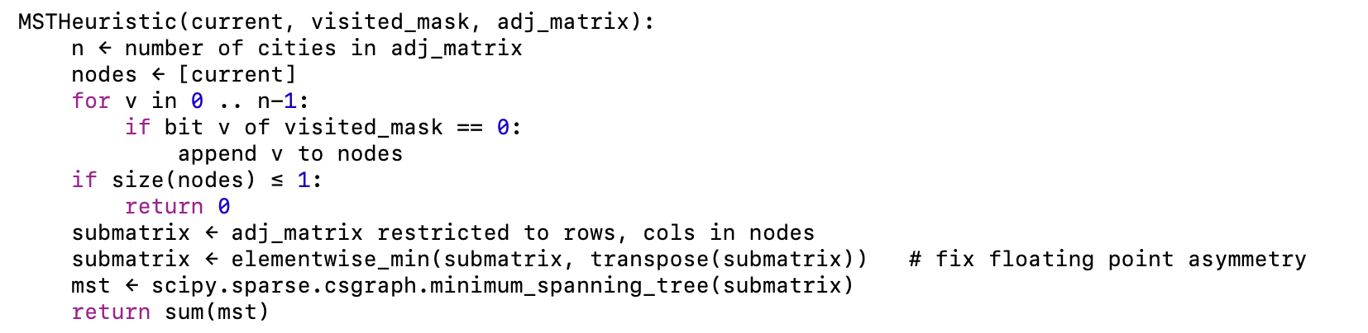
<Algorithm 1: MST Heuristic>

- A* Search with MST Heuristic
The A* search algorithm explores the solution space of the TSP in a best-first manner. Each partial tour is evaluated by $f\left(x\right)=g\left(x\right)+h\left(x\right)$, where $g(x)$is the accumulated cost of the tour so far, and $h(x)$ is a heuristic estimate of the remaining cost. In the implementation, $h(x)$ is given by the MST heuristic over the unvisited cities.
As the MST heuristic is both admissible and consistent as mentioned, A* is guaranteed to return an optimal solution. Admissibility ensures that the first complete tour found corresponds to the global optimum, while consistency ensures that once a state has been expanded, it does not need to be revisited, improving search efficiency.
Although these guarantees, the exponential growth of the TSP state space causes the number of expanded nodes and runtime to increase rapidly with the number of cities. As a result, A* becomes intractable as the scale of the problem gets larger.

Q1. Implementation Details: State Representation
In the implementation of A*, each search node is represented as a tuple consisting of the current city, the set of visited cities, and the accumulated cost. The visited set is encoded as a bitmask, where the i-th bit indicates whether city I has already been visited. This representation was chosen over the List of Python that was used in part 1, because it ensures constant-time membership checks and efficient hashing when storing states in dictionaries. More importantly, it makes it straightforward to prevent revisiting cities: before expanding to a successor, it simply checks whether the corresponding bit is set. This eliminates redundant expansions and reduces memory overhead, which is especially important as the number of cities increases and the A* search tree grows exponentially.

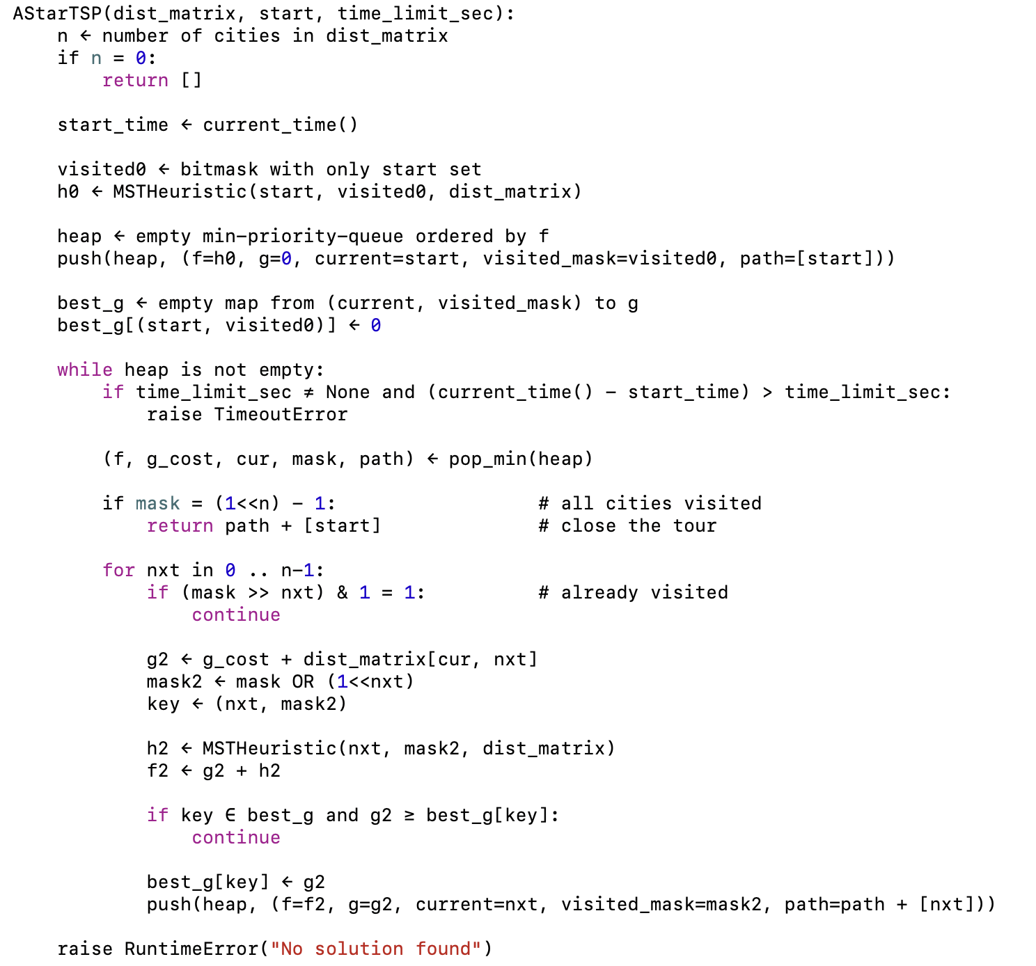
<Algorithm 2: A*>

- Experiment Setup
To evaluate the A* algorithm with the MST heuristic and compare it to the greedy algorithms, we reused the same random adjacency matrices for problem sizes $n ∈\{5, 10, 15, 20, 25, 30\}$. Each algorithm was executed on all instances, and performance was measured by medians of wall-clock time, CPU time, and tour cost, respectively, consistent with the metrics from part 1.
Since the runtime of A* increases rapidly with the problem size due to exponential growth in the number of expanded nodes, experiments were run only until A* became infeasible within a reasonable time limit (approximately one minute). If A* timed out on a particular instance, that instance was excluded from the comparison. Moreover, if five consecutive timeouts occurred at a given size $n$, larger sizes were skipped entirely to reduce overall runtime.
For each problem size where A* completed, the same instances were also used to evaluate the Nearest Neighbor (NN), Nearest Neighbor with 2-Opt (NN+2Opt), and Repeated Randomized Nearest Neighbor (RRNN, with $k = 3$ and $num repeats = 20$). To highlight the relative performance, the values for NN, NN+2Opt, and RRNN were divided by the corresponding values of A*, and the resulting ratios were plotted against the number of the cities, thereby generating four figures:
- Ratio of wall-clock times (
- Ratio of CPU times
- Ratio of tour costs
- Number of nodes expanded

- Results and Discussion
Figure 1 presents the median tour cost ratios of NN, NN+2Opt, and RRNN relative to A*. By definition, A* always produces the optimal tour cost, so it serves as the baseline of 1.0. As expected, none of the heuristic methods exactly matches the optimal solutions. NN consistently exhibits the highest relative costs, reflecting its purely greedy construction. NN+2Opt improves significantly upon NN, reducing the cost gap by performing local refinements. RRNN achieves the closest result to A* overall, often outperforming NN+2Opt, and demonstrates that randomized restarts combined with local improvement can approach near-optimal tours. The clear trend is that heuristics provide suboptimal but practical solutions, with RRNN striking the best balance between accuracy and scalability.
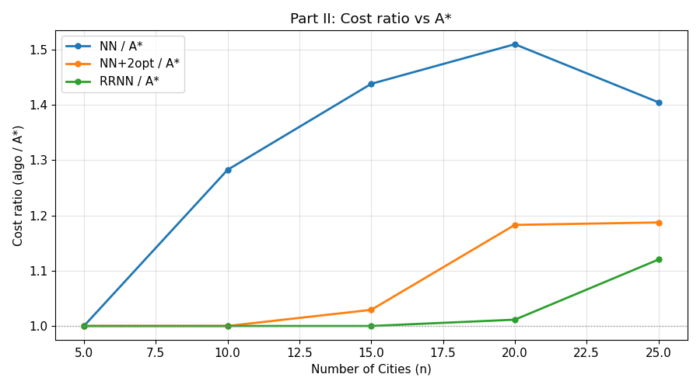
<Figure 1: Cost vs Cities>
Q2 & Q3. Runtime and Node Expansion Analysis
Figures 2 and 3 present the median CPU times and wall-clock runtimes, respectively. A* quickly becomes infeasible as the number of cities grows. In our experiments, A* completed within the one-minute limit only up to problem sizes of $n = 25$; for larger instances, consecutive timeouts prevented further runs. This indicates that the algorithm’s scalability is fundamentally constrained by the exponential growth in search space.
The primary factor driving the runtime increase is the number of nodes expanded. Here, nodes are counted as expanded when the MST heuristic is computed on it. Each node expansion requires evaluating the MST heuristic on the remaining unvisited cities, which is a lot expensive. As shown in the Figure 4, the number of expanded nodes grows much faster than linearly with the number of cities. This explains why the runtime curve rises so steeply: adding only a few more cities multiplies the number of possible partial tours and forces the algorithm to expand exponentially more nodes.
From a software engineering perspective, the choice of bitmask representation for visited sets allowed efficient state management and quick checks for revisits, but it does not fundamentally alleviate the combinatorial explosion. For potential improvements more aggressive pruning strategies, tighter lower bounds for the heuristic, or parallelization of the search process could be made.

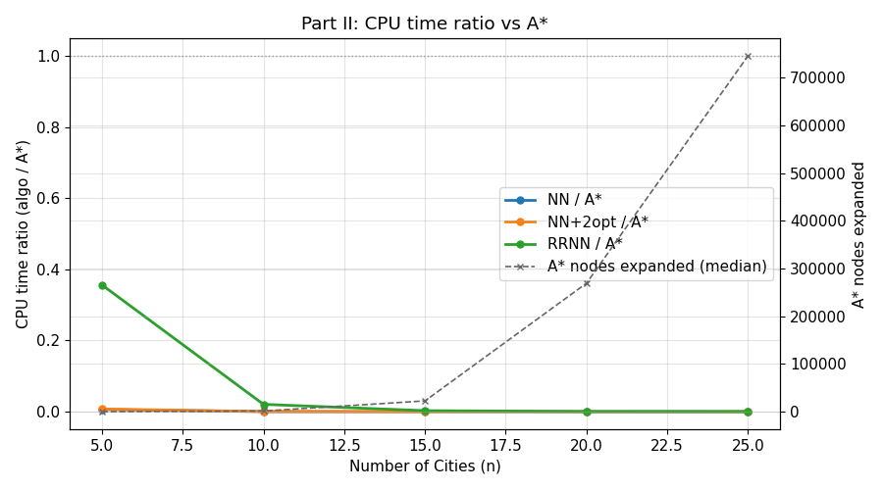
<Figure 2: CPU time vs Cities>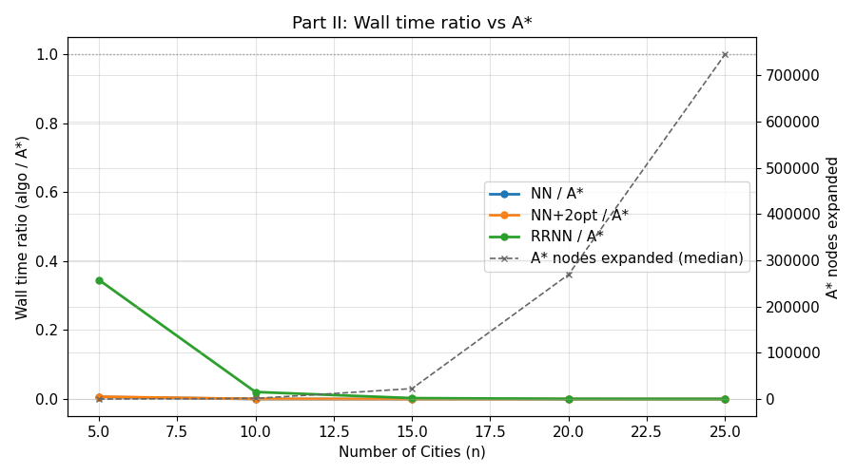
<Figure 3: Runtime vs Cities>

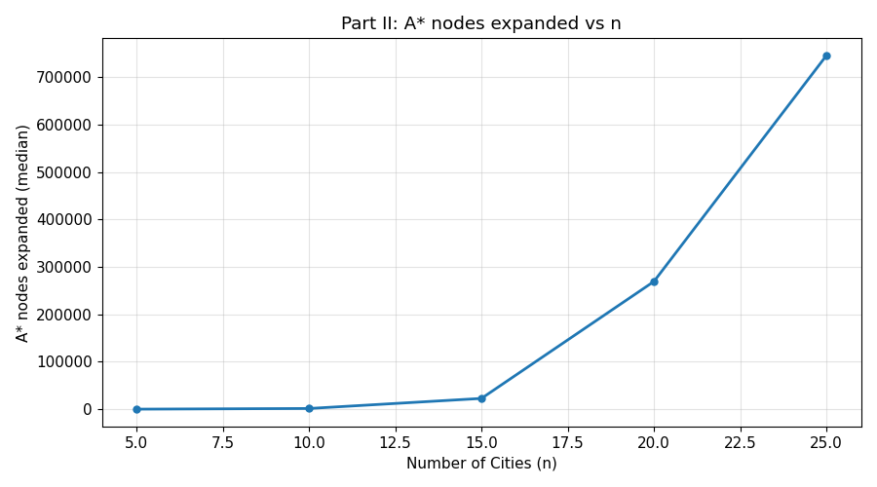
<Figure 4: Number of Nodes Expanded vs Cities>

Q4. Comparative Analysis and Practicality of A*
While A* consistently achieves the optimal tour cost, its runtime grows prohibitively with problem size due to the exponential increase in expanded nodes. In practice, this makes A* infeasible beyond small instances. By contrast, NN, NN+2Opt, and RRNN sacrifice optimality but remain computationally tractable even at larger sizes such as $n = 30$. Among them, RRNN achieves the lowest relative costs while maintaining runtime under a fraction of a second, showing a favorable trade-off between solution quality and scalability. This contrast highlights that A* is primarily of theoretical value, serving as a baseline to assess heuristics, but it is not a practical choice for real-world TSP instances where scalability is critical. In real applications, heuristics methods such as NN+2Opt and RRNN provide far more usable performance despite their lack of guaranteed optimality.

